CHAPTER 1

INTRODUCTION

  - Introduction to mobile robots

Future technology is increasingly dependent on mobile robots. They have versatile capability of operating in hostile environments, carry out routine tasks like monitoring safety or guarding houses, and are some examples to be mentioned. Mobile robots do require a high level intelligence and adaptively through senses because the mission cannot be exactly preplanned in the working environment. They mostly comprise of complex systems consisting subsystems, each for handling motion, sensory, piloting, navigation and communication. Mobile robots are available in various physical forms ranging from smallest robot in the scale of centimeter, weighing couple of grams to the biggest one, huge working machines weighting several tons. It might be necessary for the mobile robot to make physical contact with the environment by using a tool or manipulator, but in many cases only sensors are required like in monitoring or surveillance tasks.

Most mobile robots locomote with the help of typical wheels. Mobile robots may have different number of wheels according to the need of the application. For increased stability of mobile robots, we may add more number of wheels to it, to keep it stable even in undulating surfaces and prevent it from tipping over. But increasing the number of wheels constraints the mobility of the robot. And also as the contact surface with the ground increases, there is overall reduction in efficiency of the robot and more energy is consumed. But even adding more wheels will keep the robot balanced for only a range of orientation of the underlying surface. If the inclination or undulations are greater than the range that the robot can tolerate, it will often result in tipping over of the robot. All of these problems come down to the size and the shape of the wheel, which is always a constraint in conventional mobile robots.

  - Application of mobile robot in harsh environment

Robots now come in numerous forms and sizes, each possessing vastly different functions and intended for deployment in very different circumstances. Some common classifications include wheeled mobile vehicles, unmanned aerial vehicles, humanoid robots, serial-link manipulators, snake robots and legged robots. Nevertheless, the control of these robots is challenging due to the variation and unpredictability of the environments. Harsh environment is a broad term that can refer to any environment that is hazardous to agents (human or robot etc.) within it.

In Oil and Gas industry, In-pipe inspection robots (IPIRs) are used to detect cracks, corrosion and other types of defects which can lead to pipe failure. These robots, equipped with non-destructive testing (NDT)-based sensors, are inserted internally into pipelines and propelled along the pipeline network.

The applications of mobile robotics technologies for underwater and deep-sea activities are vast. One such application is the use of robots for exploration activities in ice-covered waters. Traversing in the slippery ice terrain is a challenging task. Robots must be specifically designed to move through such terrain. And with the absence of GPS signals in these waters, localization of the robot is achieved by the use of acoustic beacons fixed onto ice along the intended path of the vehicle.

A number of planetary robots have been developed for operation in Mars. These systems are tasked with objectives such as sampling local soil and rocks, mapping the environment, capturing images of key landmarks, and monitoring local environment conditions. The Curiosity rover system is the most current rover in operation on Mars, possessing a number of notable features to enable it to traverse the challenging Martian terrain

  - 1.2 Challenges faced by mobile robots in rough terrain

Traversing the rough terrain using a mobile robot pose various challenges to be tackled for the smooth operation of the robot. First challenge is to accomplish motion in the undulating terrain and maintaining the robot’s balance without it tipping over. Most of the robots resolve this issue by adding more number of wheels to the robot platform or changing the angle and orientation of the wheel setup. But this comes with a huge compromise of mobility. Higher number of wheels may be a hindrance to the mobility and allows only limited range of motion.

Secondly, the process of navigating through rough terrain may be a problem when operating in remote locations. An array of sensors needed to be mounted onto the robot platform to collect various geographical data to allow motion through unknown terrain. The controller must entirely rely on the sensor feed for controlling the robot. Also avoiding obstacle is another challenging task. Obstacle avoidance using machine vision is the most appropriate choice because other form of sensor detection is not reliable.

  - Spherical Robot and its advantages over conventional Robots

Mobility is a very crucial feature of mobile robots. The Omni-directional motion is favored, for many applications. The purpose of this project is to introduce a new mobile robot and analyze its construction and motion properties. The spherical construction offers extraordinary mobility option in cases where turning over or falling down are risks for the robot to continue motion. Its capability to recover from collisions with obstacles or another robots traveling in the environment makes it much more reliable. But a downside of this robot is it’s impossible to install a manipulator but different sensors for environment perception and navigation are easy to install. Mobility of the robot is based on disturbing the system equilibrium by unbalancing the Inside Drive Unit IDU. IDU is moved by a motor driven wheel that can be turned to cause the heading of the motion to change.

The spherical exo-skeleton provides the robot with maximal stability in the absence of orientation preference, and also the ability to roll in all directions rather than one, as provided by the wheel. The outer perimeter of the robot exo-skeleton and therefore relatively large in dimension, thus providing the ability to roll over rough terrain with relative ease. Through proper material selection, the exoskeleton can be fitted with a variety of sensors and other hardware for sensing the environment. The internal motion mechanism will provide the robot with rapid maneuverability by enabling it to quickly accelerate and decelerate, or move with constant velocity. The propulsion mechanism will also allow the robot to climb slopes of considerable inclination and traverse terrain with significant undulations.
CHAPTER 2

PROBLEM DEFINITION

The objective of this project is to design and develop a spherical mobile robot that has improved mobility and maneuverability than existing wheeled and track-based mobile robots. Incorporating a control system and interfacing various sensors with the controller and create an active balancing system to counter any unbalanced oscillations in the system. Also assemble all the components to form the IDU and to ensure uniform symmetrical distribution of mass. Interfacing the robot with a remote device and remotely actuating using a wireless connection.

2.1 Existing System

Locomotion of a mobile robot through a rough terrain is a challenging task. Many wheel and track-based robots have been developed to tackle such problems, but these robots only provide a solution to some extent. At last it all comes down to the size of the wheel and its ability to move in undulated environment. Wheels have always been a constraint for mobile robots while traversing through rough terrain as they would eventually get stuck if the undulation is much greater in size than the wheel itself. Also there is a higher chance for the robot to tip over when the robot is unable to orient itself in a stable position.

Disadvantages of existing system:

- Constrained mobility- For the mobile robots, constraints on their wheel mechanisms prevents sideways movements without preliminary maneuvering. These vehicles are quite restricted in their motion particularly when operating in tight environments.

- Possibility of tipping – If Based on the inclination and the surface undulation, the mobile robot tends to take the orientation parallel to the surface its traversing on. Mobile robots designed for such terrain have a limited range up to which orientation can be kept balanced and after that it tends to tip over.

- Misorientation – As the mobile robots take the orientation of the surface it travers upon, it can cause the disorientation of many sensory that could cause the sensors to pick up wrong data.

- Collision recovery – A mobile robot when traversing through a rough condition, there is high probability that it might be impacted by the external object thus causing damage to the actuating mechanism. Also after collision the robot typically cannot recover and tends to tip over or misaligns its orientation after which the robot cannot be worked properly.
2.2 PROPOSED SYSTEM

The spherical mobile robot has been developed with an objective of having improved mobility and maneuverability than existing wheeled and track-based mobile robots. It consists of an external spherical skeleton, which encloses an inner motion mechanism and an intelligent control system. The spherical exo-skeleton provides the robot with maximal stability in the absence of orientation preference, and also the ability to roll in all directions rather than one, which is not possible using the wheel. The outer perimeter of the robot exo-skeleton and therefore relatively large in dimension, thus providing the ability to roll over rough terrain with relative ease.

The advantages of this system are:

- Increased mobility and maneuverability
- Provides maximum stability in the absence of orientation preference
- Ability to roll over rough terrain with relative ease
- Prevent mechanical damage to the inner mechanism

2.3 Methodology

- Motion Dynamics of the system
- Orientation of the robot
- Steering of the robot
- Controlling using remote devices

2.3.1 Motion Dynamics of the system
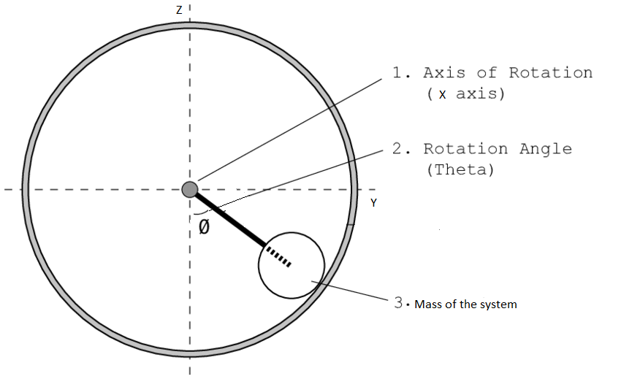
Fig 2.1 Motion Dynamics of the System

The motion of the robot can be achieved by shifting the mass of the system by an angle theta in the same vertical plane. Due to this apparent shift in Center Of Mass (COM) the outer spherical shell tends to rotate in the same direction. This causes the robot to roll over. The system tends to get back to the original position to maintain the balance but to keep the robot moving in the desired direction, the mass is continuously shifted. Thereby causing the robot to move by rolling in the specified direction.
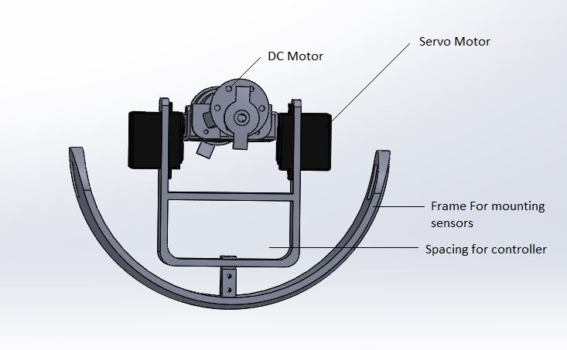
Fig 2.2 Bottom Frame

The Bottom frame is designed to mount camera, other optional sensors and batteries.
The batteries makes up for the most of the mass of the system.

The robot motion is achieved with the help of a pair of DC motors and a pair of Servo motors. The forward/backward motion is achieved by actuating the dc motors. The DC motors are controlled using the L298N motor driver. DC motors are given 12v DC power supply from batteries.

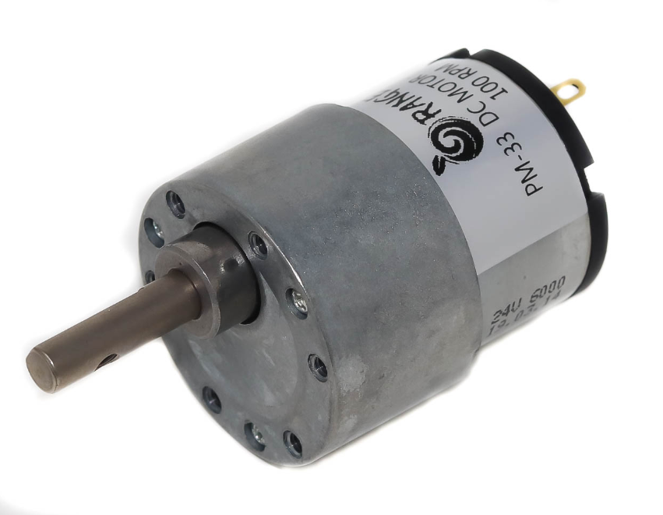
Fig 2.3 DC Motor

2.3.2 Orientation of the robot

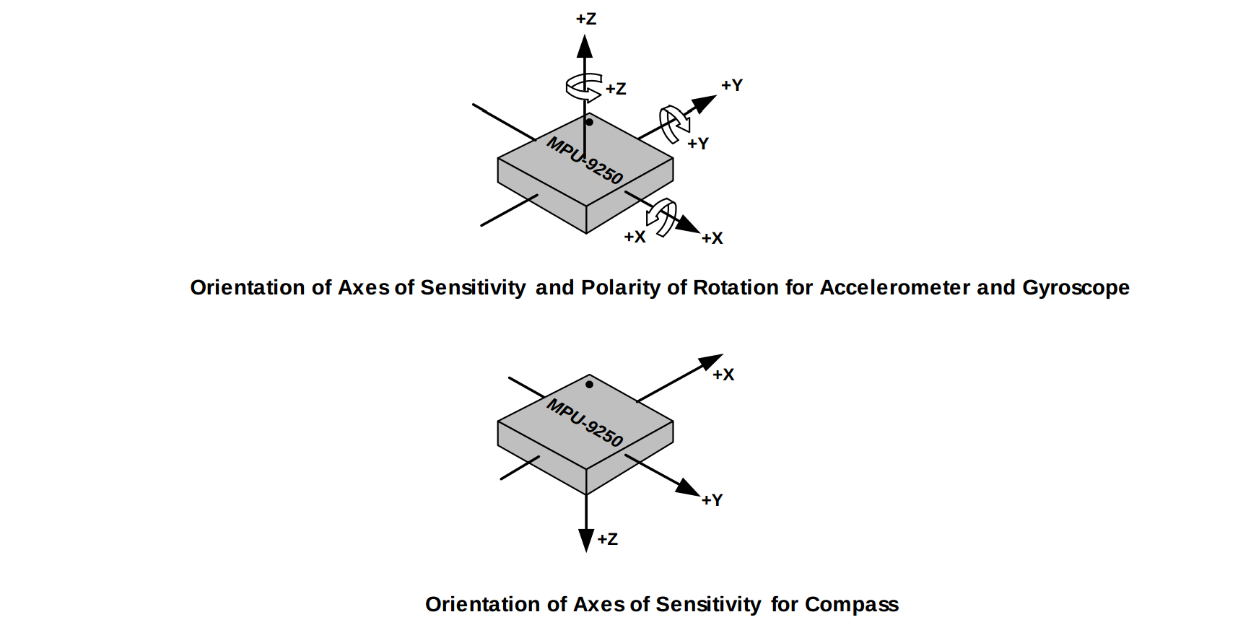
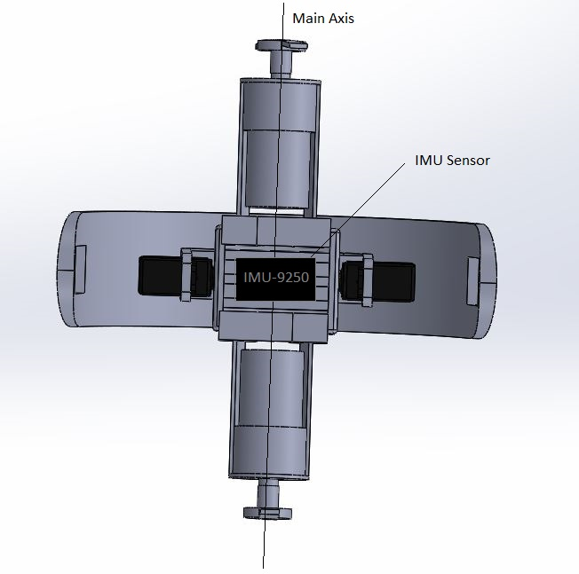
Fig 2.4 Orientation of the Robot
The Orientation of the robot is measured by using an Inertial Measurement Unit Sensor (IMU) .An MPU-9250 sensor is used which consist of 3 Axis Accelerometer and 3 Axis gyroscope. The Accelerometer provides the acceleration data of the robot, whereas the Gyroscope provides the rotation about each of X, Y, Z axes. The Sensor is placed at the middle of the main frame axis of the robot and is enclosed inside a 3D printed part to provide protection and prevent the misalignment of the sensor.

It is very crucial to know the orientation of the robot to control its direction of motion. Rotation about X axis of the sensor provides the pitch control and rotation about Y axis provides the Yaw control of the robot.

2.3.3 Steering Of Robot

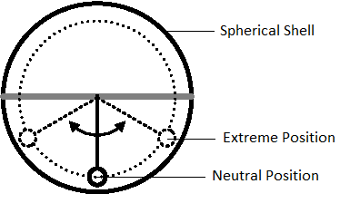
Fig 2.5 Steering of Robot

The steering of the robot is achieved by shifting COG towards the sides. This is performed by actuating the servo motors. Actuating the servo motors tends to rotate the hanging frame about the Y axis of the robot. The initial position of the hanging frame may vary depending upon the current orientation of the robot with respect to the underlying surface. The maximum rotation about Y axis is 60 deg both clockwise and counter clockwise direction from the neutral position of the robot i.e. with a range of motion of -60 to 60 deg from neutral position. But this range of motion may vary for different inclinations of the traversing surface. This is dynamically changed by analyzing the data from the MPU-9250 Gyroscope sensor.

Steering the robot by an angle of 90 deg is not possible. The robot takes a longer curved path to completely turn towards the specified direction. During the whole turning process the vertical frame is maintained with the same side tilt until the complete turn is accomplished.

The robot is steered with the help of a pair of MG995 servo motors. The servo motors are controlled using Adafruit 16 channel servo driver. They are supplied with 9V power supply.

2.3.4 CONTROL USING REMOTE DEVICES

The spherical robot can be remotely controlled using any other device fitted with a display and a Wi-Fi connection with the local server of the robot. As the robot switches ON, the Raspberry Pi runs a web server in its memory for interacting with its control system. Controlling the spherical robot is as easy as connecting the on board Wi-Fi of the device with the local server of the robot and entering the URL in any native browser. The control keys and the specific instructions are displayed as a webpage on the device that is accessing the web server of the robot. The web page displays a virtual controller to control the robot.

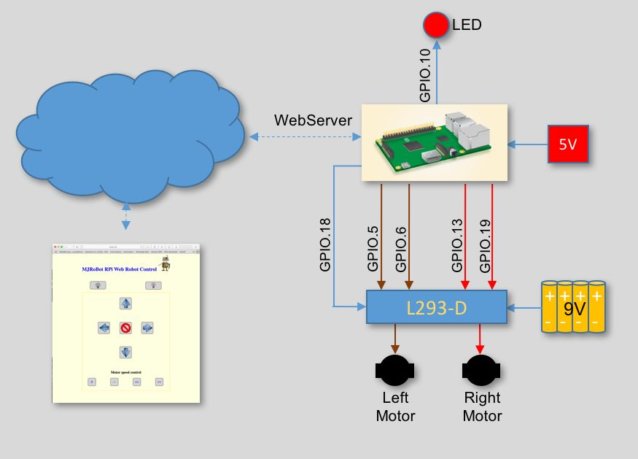

Fig 2.6 Deploying webserver in Raspberry pi 3

CHAPTER 3

FEASIBILITY STUDY

3.1 ECONOMICAL FEASIBILITY

Table 3.1 Cost of the Purchased Components

S No | Bill of materials | Quantity | Cost (Rs.)
1 | Raspberry Pi 3B+ | 1 | 3000
2 | DC Geared Motor | 2 | 656
 | L298N Motor Driver | 1 | 150
3 | L298N Motor Driver | 1 | 150
4 | MG995 Servo Motor | 2 | 550
5 | Adafruit Servo Driver | 1 | 450
6 | MPU-9250 | 1 | 350
7 | 3D printed components | As required | 3000
8 | Battery and Adapter | 1 | 300
9 | Wires | As required | 200
 |  | Total | 8656

Table 3.1 represents the cost of the components. It is invested to bring a fruitful result. Hence, the project is economically feasible and it is followed by design and fabrication process.
3.2 OPERATIONAL FEASIBILITY

The entire working of the spherical robot can be achieved using the spherical exo-skeleton, a pair of DC motors to control the forward/backward motion of the robot, a pair of MG995 Servo motors to control the side sway and steering the robot in specified direction. L298N driver is used to control the forward/backward operation of the dc motors and Adafruit 16channel Servo Driver is used for smooth controlling of the servo motors. An MPU-9250 sensor is used to measure the orientation and the acceleration of the spherical robot. This whole complex system is controlled using Raspberry PI 3B+ and remote controlling of the robot is made possible using a python-django server deployed in the Raspberry Pi memory. No other robots have used such methods to interface with the robot controls. It provides an intuitive and a user-friendly way of controlling the robot and viewing the acquired the sensor data.

3.3 TECHNICAL FEASIBILITY

The components used for this project are available in many online stores and are affordable. The software used for this project has open source licensing and can be easily modified according to our needs. The design which has to be implemented can be simulated through the available software and prototype can be developed according to the concept. The sample prototype represents the concept or the process which is going to be implemented. After attaining the results of prototype, the concept which has designed can be fabricated into a product. The proposed system is technically feasible and makes the existing system incompetent. The additional features like camera and other sensors can be easily added to the system for extra utility purpose.

CHAPTER 4

DESIGN OF THE MODEL

4.1 COMPONENTS USED

The components required for the fabrication of project are explained below in detail.

List of components:

- Raspberry PI 3 B+
- MPU-9250
- Tower Pro MG995 Servo Motor
- Adafruit 16 Channel Servo driver
- 12V DC geared motor
- L298N Motor Driver
- 5V Power supply
- 12V power supply
- Adapter
- Wi-Fi Router

4.1.1 Raspberry Pi 3B+

The Raspberry Pi 3B+ is a tiny credit card sized computer with versatile capability. It features a powerful CPU and 1 Gigabyte of ram to satisfy all the computational needs. Due to its versatile capability, it can be used as a controller for any projects. To facilitate the simple interfacing of external hardware with the Raspberry Pi board, it is provided with 40 GPIO pins each having its own purpose. It is also provided with an array of ports that include USB ports for communicating with external hardware. A mouse and a keyboard can be plugged in on the go for controlling and interacting with the operating system of the raspberry PI. It has a dedicated micro USB slot used as power supply. For this project, the operating system (Raspbian OS) is installed on a 16Gb SD card and inserted in the micro SD slot provided on the controller board.

Fig.4.1. Raspberry PI 3 Model B+
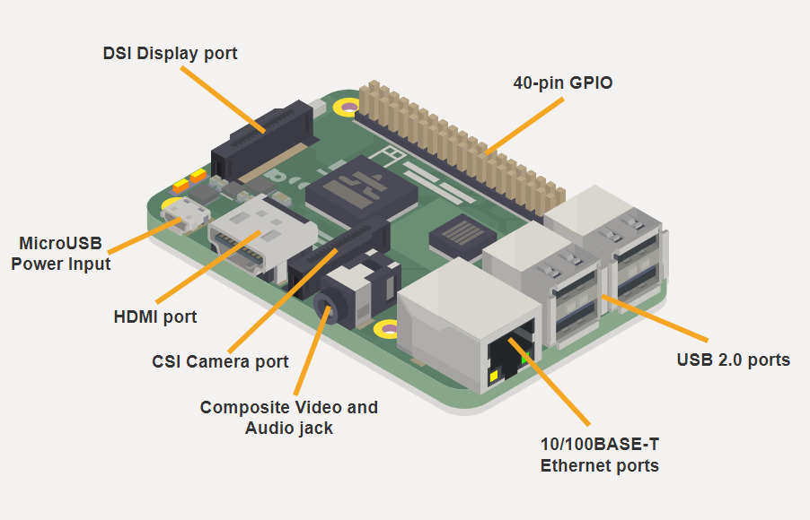

GPIO pins on Raspberry PI
A powerful feature of the Raspberry Pi is the row of GPIO (general-purpose input/output) pins along the top edge of the board. A 40-pin GPIO header is found on all current Raspberry Pi boards (unpopulated on Pi Zero and Pi Zero W). Prior to the Pi 1 Model B+ (2014), boards comprised a shorter 26-pin header. The Raspberry Pi 3 Model B+ board contains a single 40-pin expansion header labeled as 'J8' providing access to 28 GPIO pins. (Pins 1, 2, 39 & 40 are also labeled below.)
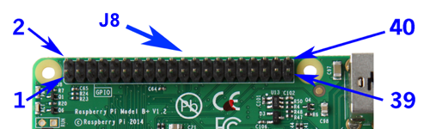
Fig 4.2 GPIO pins on Raspberry Pi
Any of the GPIO pins can be designated (in software) as an input or output pin and used for a wide range of purposes.
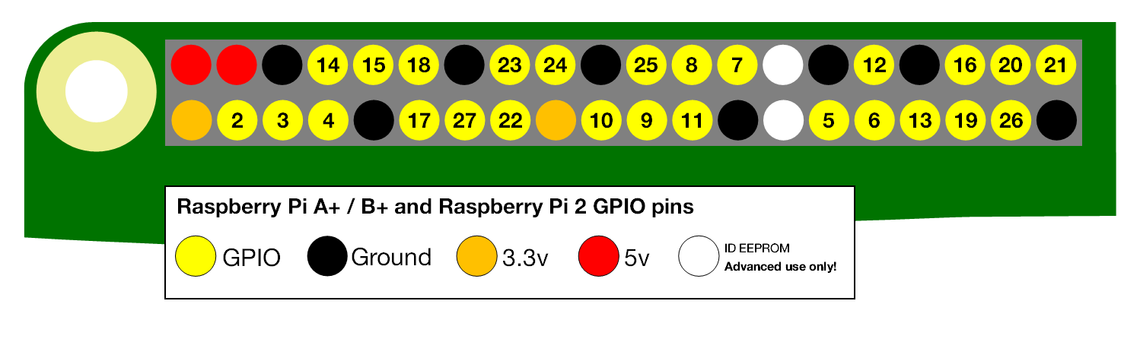
Fig 4.3 GPIO pins Layout

Voltages
Two 5V pins and two 3V3 pins are present on the board, as well as a number of ground pins (0V), which are unconfigurable. The remaining pins are all general purpose 3V3 pins, meaning outputs are set to 3V3 and inputs are 3V3-tolerant.
Outputs
A GPIO pin designated as an output pin can be set to high (3V3) or low (0V).
Inputs
A GPIO pin designated as an input pin can be read as high (3V3) or low (0V). This is made easier with the use of internal pull-up or pull-down resistors. Pins GPIO2 and GPIO3 have fixed pull-up resistors, but for other pins this can be configured in software.
4.1.2 MPU-9250

The MPU-9250 is a 9-axis Motion Tracking device that combines a 3-axis gyroscope, 3-axis accelerometer, 3-axis magnetometer and a Digital Motion Processor (DMP) all in a small 3x3x1mm package available as a pin-compatible upgrade from the MPU-6515. With its dedicated I2C sensor bus, the MPU-9250 directly provides complete 9-axis Motion Fusion output. The MPU-9250 Motion Tracking device, with its 9-axis integration, on-chip Motion Fusion, and run-time calibration firmware, enables manufacturers to eliminate the costly and complex selection, qualification, and system level integration of discrete devices, guaranteeing optimal motion performance for consumers. Gyroscope can measure the tilt and lateral orientation of the bot whereas accelerometer can only measure the linear motion of the bot. MPU-9250 is also designed to interface with multiple non-inertial digital sensors, such as pressure sensors, on its auxiliary I2C port. The MPU-9250 is enclosed inside a 3D printed part to avoid damage and placed at the middle of the bot to prevent the misalignment of the sensor.

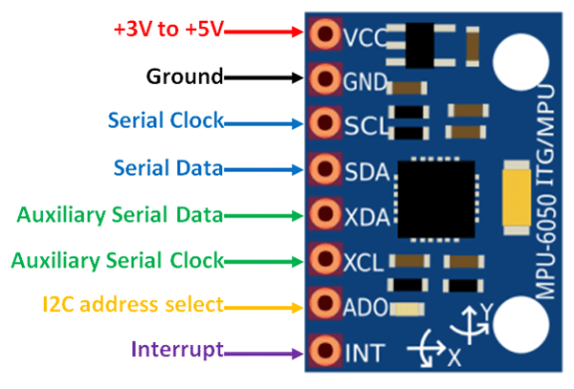
Fig 4.4 Pin Configuration Diagram of MPU-9250
4.1.3 Servo Motor:
A servo motor is an electrical device which can push or rotate an object with great precision. If you want to rotate and object at some specific angles or distance, then you use servo motor. It is just made up of simple motor which run through servo mechanism. If motor is used is DC powered then it is called DC servo motor, and if it is AC powered motor then it is called AC servo motor. We can get a very high torque servo motor in a small and light weight packages.

MG995 servo provides a fast control response and constant torque throughout the servo range. It is a closed loop system where it uses positive feedback system to control motion and final position of the shaft. Here the device is controlled by a feedback signal generated by comparing output signal and reference input signal. Here, reference input signal is compared to reference output signal and the third signal is produces by feedback system. And this third signal acts as input signal to control device. This signal is present as long as feedback signal is generated or there is difference between reference input signal and reference output signal. So, the main task of servomechanism is to maintain output of a system at desired value at presence of noises. These servos control the swaying and steering of bot in the specified direction.
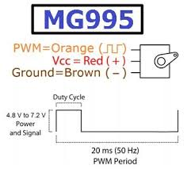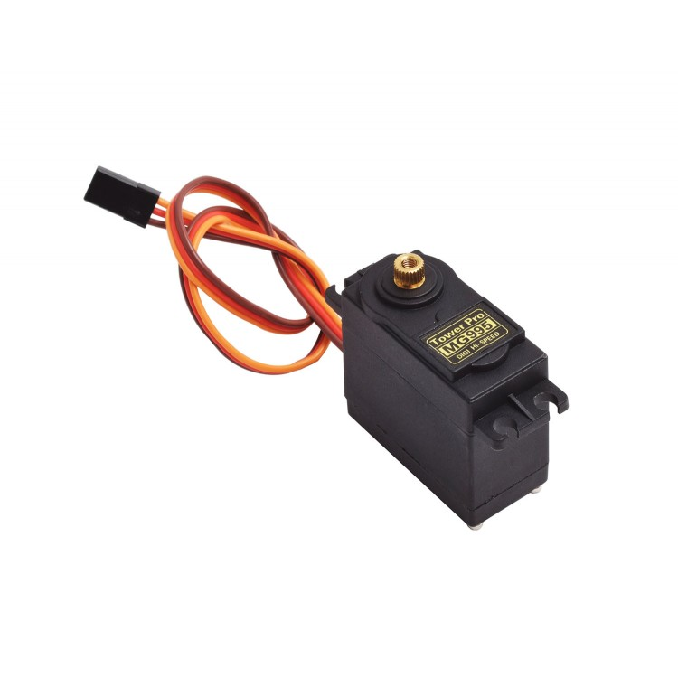
Fig 4.5 Servo Motor Pinout Fig 4.6 MG995 Servo Motor
4.1.4 Servo Motor Drivers

Servo motors are often driven using the PWM outputs available on most embedded MCUs. But while the Pi does have native HW support for PWM, there is only one PWM channel available to users at GPIO18. That kind of limits your options if you need to drive more than one servo or if you also want to dim an LED or do some sort of other PWM goodness as well. But PI does have HW I2C available, which we can use to communicate with a PWM driver like the PCA9685, used on Adafruit's 16-channel 12-bit PWM/Servo Driver. Using this breakout, you can easily drive up to 16 servo motors on your Raspberry Pi using a Python library. The Adafruit servo driver is the best solution
for controlling more than one servo.

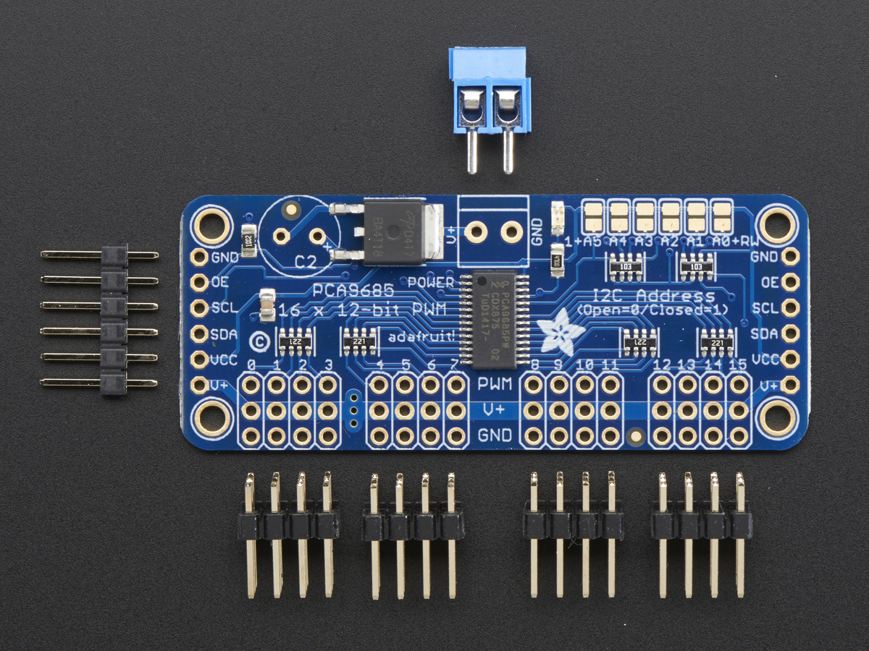
Fig 4.7 Adafruit Servo Motor Driver Pinout

4.1.5 DC MOTOR

Orange PM33 12v 100RPM DC motor for DIY projects is a simple 100 RPM 7.36N-cm side shaft DC gear motor. This is a new compact size motor at a low cost. The supply voltage range is 10-12V with the polarity markers at the base of the motor. The overall body of the motor is made up of metal. The motor has a D type shaft with a shaft length of 21mm and a diameter of 6mm. The shaft type is D and hence the coupling arrangement can be made easily. The DC motors are coupled on opposite sides of the bot to ensure the centre of mass and to control the backward or forward motion of the bot.

Fig 4.8 PM 33 DC Motor

4.1.6 L298N DRIVER

L298N 2A Based Motor Driver is a higher power motor driver perfect for driving DC motors and Stepper motors. It uses the popular L298 motor driver IC and has an onboard 5V regulator which it can supply to an external circuit. It can control up to 4 DC motors, or 2 DC motors with directional and speed control. This motor driver is perfect for robotics and mechatronics projects and perfect for controlling motors from microcontrollers, switches, relays, etc. Perfect for driving DC and Stepper motors for micro mouse, line following robots, robot arms, etc.
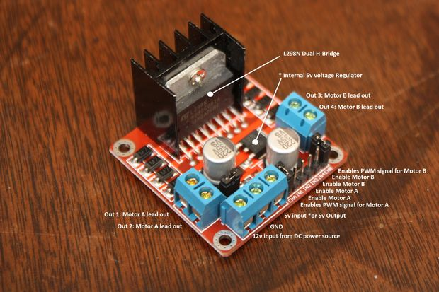
Fig 4.9 L298N Motor Driver
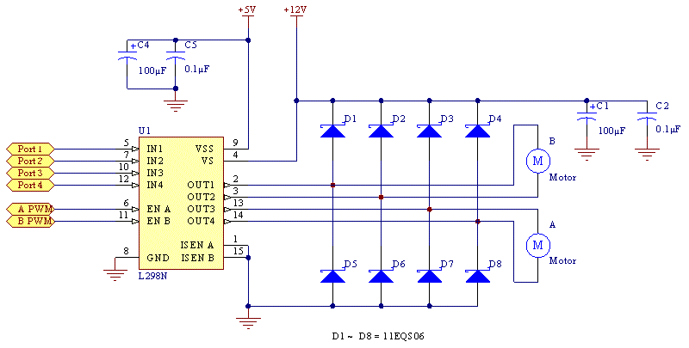

Fig 4.10 /Interfacing L298N with DC Motors
CHAPTER 5

FABRICATION PROCESS

5.1 ELECTRONIC CIRCUIT DESIGN

In this section, all the required components are interfaced with raspberry pi. Initially each device is individually connected and tested for errors.

5.1.1 Connecting servo using Adafruit servo driver

The easiest way to hook the servo breakout up to your Pi is using a breadboard and connecting it to the Pi using I2C:
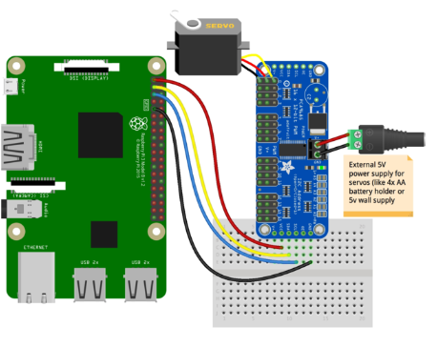
Fig 5.1 Raspberry PI with Adafruit Servo Driver

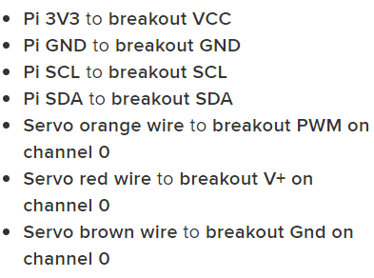

Switching directions on the servo can cause a lot of noise on the supply, and the servo(s) will cause the voltage to fluctuate significantly, which is a bad situation for the Pi. It's highly recommended to use an external 5V supply with servo motors to avoid problems caused by voltage drops on the Pi's 5V line.

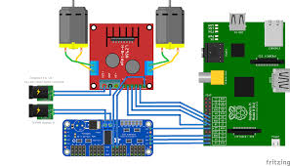
Fig 5.2 Servo Connections with Servo Driver

5.1.2 Interfacing with MPU-9250

Enabling the I2C Communication
Raspberry Pi is configured to connect with the IMU sensor using I2C communication.
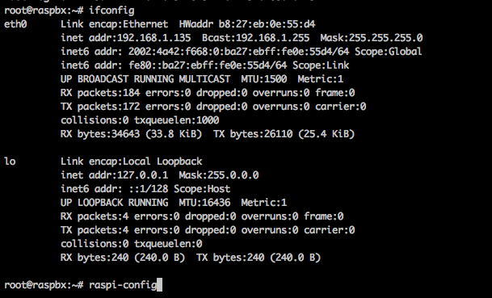
Fig 5.3a
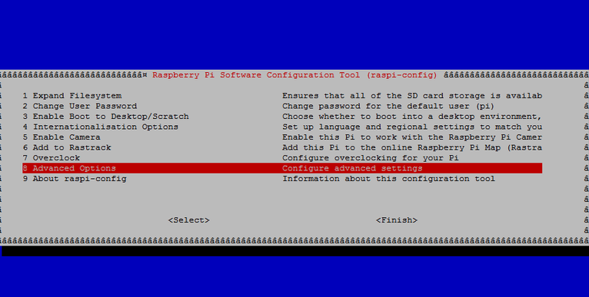
Fig 5.3b

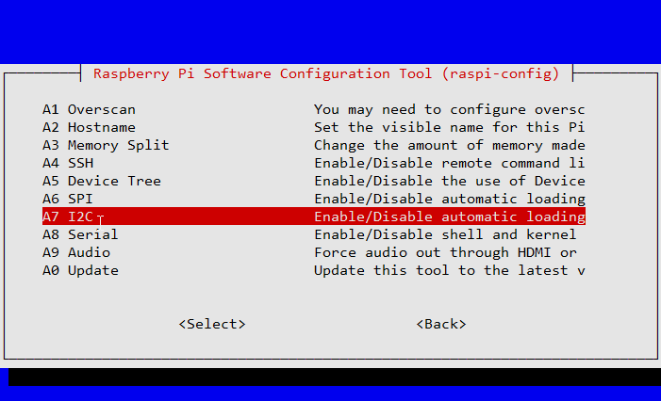
Fig 5.3c

Wiring Connections

MPU9250 | Raspberry Pi
SDA | SDA
SCL | SCL
VCC | 3 V
Gnd | Gnd
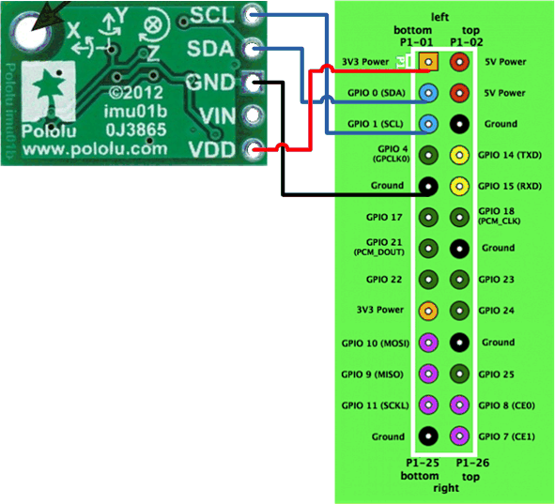
Fig 5.4 MPU-9250 with Raspberry Pi

5.1.3 Connecting an L298 With a Raspberry Pi

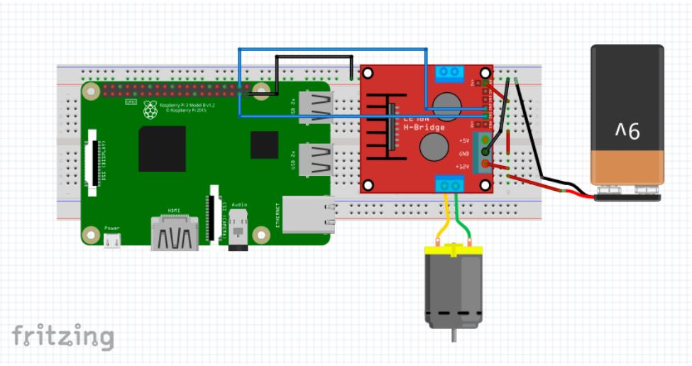

Fig 5.5 L298N Motor Driver with Raspberry Pi

L298 is known as a dual bidirectional motor driver which is based on dual H-Bridge Motor driver IC. This circuit allows you to control two DC motors independently in either direction. It also provides an onboard 5V regulator that you can use to power your 5V circuits very conveniently.

- Connect IN1 on the L298 to the Raspberry Pi’s pin number 26.
- Connect IN2 on the L298 to Raspberry Pi’s pin number 20.
- Connect the ENA and 12-volt pin to a 9-volt battery.
- Make sure the grounds of the battery, Raspberry Pi, and L298 are common.

5.1.4 Development of SOLIWORKS model
The model was developed by using solid works. It is a solid modeler, and utilizes a parametric feature-based approach to create models and assemblies. Building a model in SolidWorks usually starts with a 2D sketch (although 3D sketched are available for power users). Relations are used to define attributes such as tangency, parallelism, perpendicularity and concentricity. The dimensions in the sketch can be controlled independently or by relationships to other parameters inside or outside of the sketch.

In an assembly, the analog to sketch relations are matters. Just as sketch radiations define conditions such as tangency, parallelism and concentricity with respect to sketch geometry, assembly mates define equivalent relations with respect to the individual parts or components, allowing the easy construction of assemblies.

3D Model
DC Motor

Servo Motor

Spacing for Controller

Frame for mounting sensors

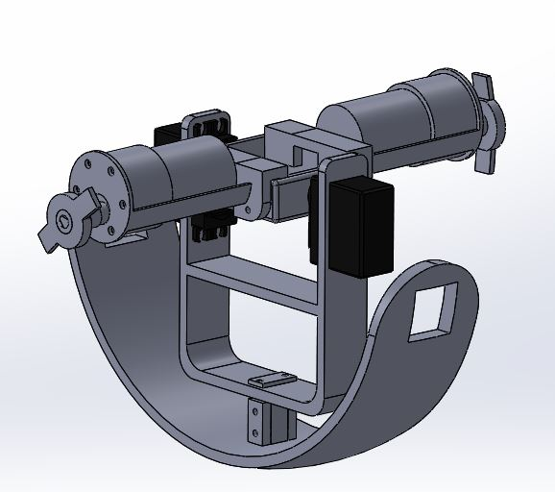
Fig 5.6 3D Models of the robot

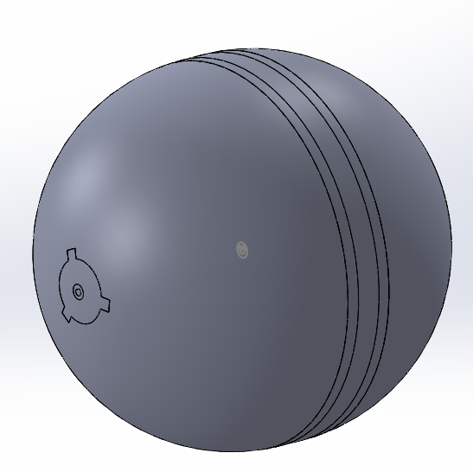

5.1.5 WORKING METHODOLOGY

The motion of the robot is achieved by shifting the center of gravity (COG) of the robot. The COG can be shifted by actuating a pair of dc motors and a pair of Servo motors. The forward /backward motion can be achieved by shifting the COG in forward/backward direction. The 12V DC motor is actuated using a L298N motor driver.
The Side swaying and steering of the robot can be controlled with the help of a pair of MG995 Servo motors. These servo motors are controlled using Adafruit 16channel Servo driver. An IMU sensor (MPU-9250) is used for measuring the rotation of the robot. This rotation data is used for countering the side swaying of the robot. Using this data, the servo is actuated in the opposite direction.

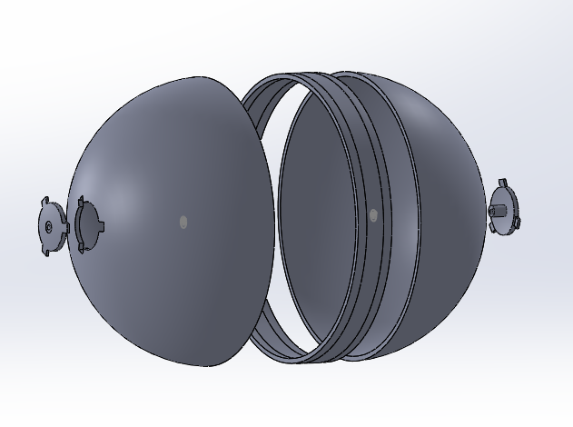
CHAPTER 6

CONCLUSION AND FUTURE SCOPE

6.1 CONCLUSION

The conventional mobile robots have a lot of useful features but has many constraints that limits its mobility. To overcome such problems, we have developed the SPHERICAL ROBOT to enable easy locomotion on undulating surfaces without the fear of the mobile robot tipping over. Also providing enhanced mobility for versatile applications and maintain the robot system in equilibrium at different orientation preferences.

6.2 FUTURE SCOPE
The capabilities of the prototype can be enhanced by
- Incorporating a camera to assist remote controlling of the robot
- Embedding sensors in the exo-skeleton to sense the data about the environment
- A reaction wheel mechanism can be incorporated to balance the side swaying of the robot as it provides a fast response time.
- Machine vision system can be integrated into the raspberry Pi for autonomous control of the robot.

APPENDIX

Raspberry Pi PROGRAMMING

# raspberry pi imports
import RPi.GPIO as GPIO
from adafruit_servokit import ServoKit
import time
#from mpu6050 import mpu6050

kit = ServoKit(channels=16)
GPIO.setmode(GPIO.BCM)
LED_PIN = 18
MOTOR_FORWARD = 23
MOTOR_BACKWARD = 24
GPIO.setup(MOTOR_FORWARD, GPIO.OUT)
GPIO.setup(MOTOR_BACKWARD, GPIO.OUT)
# to initialize the sensor
#sensor = mpu6050(0x69)

from rest_framework.views import APIView
from rest_framework.response import Response
from django.http import HttpResponse, JsonResponse

class ToggleLed(APIView):

def get(self, request):
if request.user.is_authenticated:
GPIO.setup(LED_PIN, GPIO.OUT)
if GPIO.input(LED_PIN):
GPIO.output(LED_PIN, 0)
else:
GPIO.output(LED_PIN, 1)
return Response({'status':'Led is toggled'})
return Response({'error':'Action prohibited from performing!!'})

class ForwardMotion(APIView):
def get(self, request):
if request.user.is_authenticated :
if GPIO.input(MOTOR_FORWARD) == 0:
GPIO.output(MOTOR_FORWARD, 1)
return Response({'status':'Motor in operation - Forward'})
else:
GPIO.output(MOTOR_FORWARD, 0)
return Response({'status':'Motor Stopped'})

return Response({'error':'Action prohibited from performing!!'})

class BackwardMotion(APIView):
def get(self, request):
if request.user.is_authenticated :
if GPIO.input(MOTOR_BACKWARD) == 0:
GPIO.output(MOTOR_BACKWARD, 1)
return Response({'status':'Motor in operation - Forward'})
else:
GPIO.output(MOTOR_BACKWARD, 0)
return Response({'status':'Motor Stopped'})

return Response({'error':'Action prohibited from performing!!'})

class LeftTilt(APIView):
def get(self, request):
if request.user.is_authenticated :
kit.continuous_servo[1].throttle = -0.5
kit.continuous_servo[0].throttle = -0.5
time.sleep(0.1)
kit.continuous_servo[1].throttle = 0
kit.continuous_servo[0].throttle = 0
return Response({'status':'Servo Tilted - Left'})

return Response({'error':'Action prohibited from performing!!'})

class RightTilt(APIView):
def get(self, request):
if request.user.is_authenticated :
kit.continuous_servo[1].throttle = 1
kit.continuous_servo[0].throttle = 1
time.sleep(1)
kit.continuous_servo[1].throttle = 0
kit.continuous_servo[0].throttle = 0
return Response({'status':'Servo Tilted - Left'})

return Response({'error':'Action prohibited from performing!!'})

"""class ImuData(APIView):
def get(self, request):
if request.user.is_authenticated :
accel_data = sensor.get_accel_data()
gyro_data = sensor.get_gyro_data()
imu_data = [
{'accelerometer':[accel_data['x'],accel_data['y'],accel_data['z']],
'gyro':[gyro_data['x'],gyro_data['y'],gyro_data['z']]
}
]
return Response({'data':imu_data})

return Response({'error':'Action prohibited from performing!!'})"""
REFERENCES

- Amir Homayoun Javadi A. and Puyan Mojabi ,“Introducing August: A Novel Strategy for An Omnidirectional Spherical Rolling Robot” ,Proceedings of the 2002 IEEE International Conference on Robotics & Automation Washington, DC May 2002
- Aarne Halme, Torsten Schonberg and 'Yan Wang,” MOTION CONTROL OF A SPHERICAL MOBILE ROBOT” , Helsinki University of Technology, Automation Technology Laboratory Otakaari 5A, 02150 Espoo, FINLAND
- Shourov Bhattacharya and Sunil K. Agrawal, “Spherical Rolling Robot: A Design and Motion Planning Studies”, IEEE TRANSACTIONS ON ROBOTICS AND AUTOMATION, VOL. 16, NO. 6, DECEMBER 2000

